Thumbnail Album Process
Version 1.00

Version | Changes | Date/Editor
1.0 | - Initial Release | JZ/JG – 9/1/25

Thumbnail Album Process
Raw files for thumbnails are generated by open a 3D viewer supporting the 3MF extensions in the file.
Once opened, select a view angle and zoom that better exposes the test case outcome. Then either do a screen capture to a PNG, or if the viewer has any 2D image export feature, generate an image around 1024 x 768 pixels size.
For example using MS 3D Viewer:
1)Launch the 3d Viewer. From View menu, select Shading, then Smooth Shading.
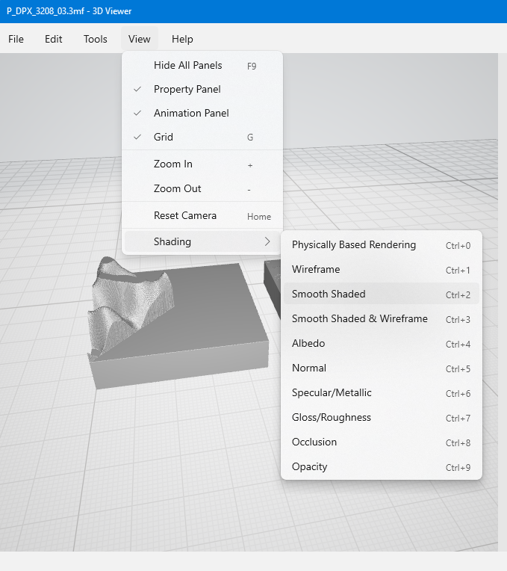
2)Load the 3MF into the 3d View Application, then rotate and size the image so that clearly shows the features of the 3d object.
3)From the File menu, select Export Image, Select the desired size (1024 x 768) and click the export button

Adding “Expected Result to Thumbnails
1)Place the thumbnail PNG file and the “Expected.png” file that I attached to the same email as this procedure into the same directory.
2)Run the following ImgMagik command line command line from the directory the thumbnails are in….
magick composite -gravity NorthEast thumbnail.png Expected.png output.png

3)This command will add “Expected Result” to the upper right hand corner of the image.
Alternatively you could manually do with a photo editor.
4) Optionally, when the viewer can’t show color and produces an output that is a monochrome version of a color 3MF, the recommendation is to add this label to the thumbnail:

Adding the new thumbnail to the 3MF File
1)The Thumbnail should have the same base names at the test file, such as “P_DPX_3208_03.png”.
2)Make sure to update the _rels/.rels file some that the relationship has the right name….
<Relationship Id="rel1xxxx" Target="/Thumbnails/P_DPX_3208_03.png" Type="http://schemas.openxmlformats.org/package/2006/relationships/metadata/thumbnail"/>

Creating a Thumbnail Album
1) Each of the test suites in the develop repository have a directory with exported thumbnail png files.
2) Add, delete, or replace thumbnails as required in the directory with all the PNG files. We will refer to this as the “Thumbnail Directory”.
3)Start Contenta Converter Premium
4)Select the “Add Photos” button, then “Add one or many photos”, and finally select the thumbnails you want to include in the album and click the Next Button
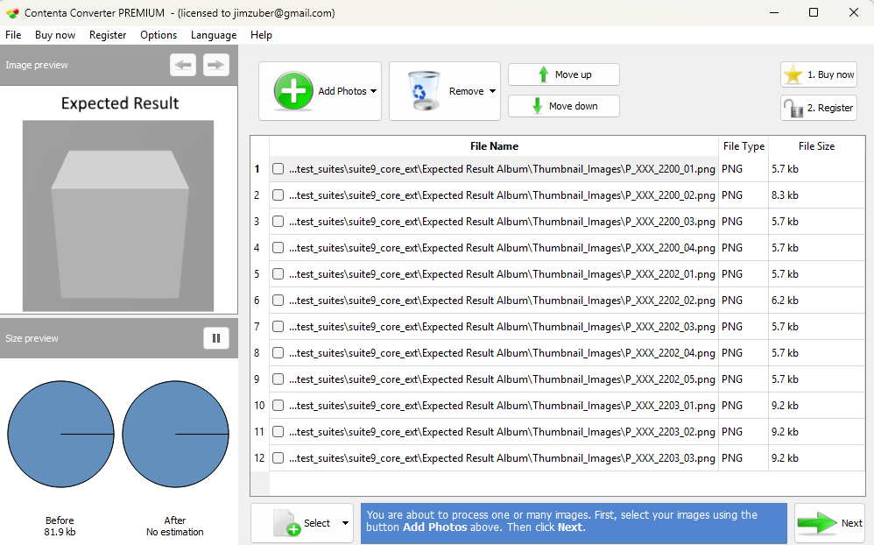

5)Select the “PDF Album” icon, then check the “make a photo Album” checkbox.
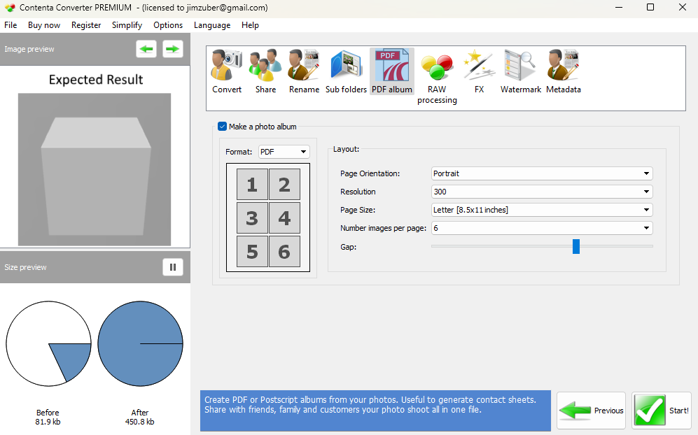
6)Then select the page orientation and number of images per page. You may need to move the “Gap” slider to create spaces between the images.
7)When do, click the Start button.
8)You will see a Save file dialog, specific the name and location of the thumbnail album and click Save.
9)The Thumbnail album will be generated.
Other resources…
1)The non stripped version of the 3MF Editor has a Tool option called “Batch Export Thumbnails” that will allow you to select a set of 3MF files and it will extract the thumbnails, placing them in a “Thumb” subdirectory below where the 3MFs were selected.
2)Below is a python program that swap out an existing thumbnail for another one in the 3MF file. If you just have a few to replace, the 3MF Editor is a better solutions. To use python script, put all 3MFs and thumbnails in same directory. Create a text file with a list if the 3MFs you want to process, then call the program Usage: python replace_zip_file.py <zip_file_list.txt>")

import zipfile
import os
import shutil
import sys

def process_zip_file(zip_path, replacement_dir):
"""
Process a single zip file: remove the target file from the Thumbnails folder
and add a replacement file from replacement_dir.
"""
# Get base name (without extension) of the zip file.
base_name = os.path.splitext(os.path.basename(zip_path))[0]
# Construct target file path inside the zip using forward slashes.
target_inside_zip = f"Thumbnails/{base_name}.png"

# Determine the replacement file path in the current directory.
replacement_file = os.path.join(replacement_dir, f"{base_name}.png")
if not os.path.isfile(replacement_file):
print(f"Replacement file not found: {replacement_file}. Skipping {zip_path}.")
return

# Create a temporary zip file for reconstruction.
temp_zip_path = zip_path + ".temp"

with zipfile.ZipFile(zip_path, 'r') as zin, zipfile.ZipFile(temp_zip_path, 'w') as zout:
# Iterate over all items in the original zip file.
for item in zin.infolist():
# Normalize the file name from the zip to use forward slashes.
normalized_name = item.filename.replace('\\', '/')
# Skip the file that we want to replace.
if normalized_name == target_inside_zip:
print(f"Deleting {item.filename} from {zip_path}")
continue
# Copy the other files exactly, preserving metadata.
data = zin.read(item.filename)
zout.writestr(item, data)

# Now add the replacement file into the Thumbnails folder.
print(f"Adding replacement file for {target_inside_zip} in {zip_path}")
with open(replacement_file, 'rb') as rf:
file_data = rf.read()
zout.writestr(target_inside_zip, file_data)

# Replace the original zip file with the updated one.
shutil.move(temp_zip_path, zip_path)
print(f"Updated {zip_path} successfully.")

def main():
# Ensure the user provided the path to the text file listing zip file names.
if len(sys.argv) < 2:
print("Usage: python replace_zip_file.py <zip_file_list.txt>")
sys.exit(1)

zip_file_list_path = sys.argv[1]

# Read zip file paths from the text file (one per line).
with open(zip_file_list_path, 'r') as f:
zip_files = [line.strip() for line in f if line.strip()]

# Use the current working directory for locating replacement files.
current_dir = os.getcwd()

for zip_file in zip_files:
# If zip_file is a relative path, convert it to an absolute path.
if not os.path.isabs(zip_file):
zip_file = os.path.join(current_dir, zip_file)
if os.path.isfile(zip_file):
process_zip_file(zip_file, current_dir)
else:
print(f"Zip file not found: {zip_file}")

if __name__ == '__main__':
main()

Alternative: Create thumbnail PDF in Photoshop
In File Automate Contact Sheet II
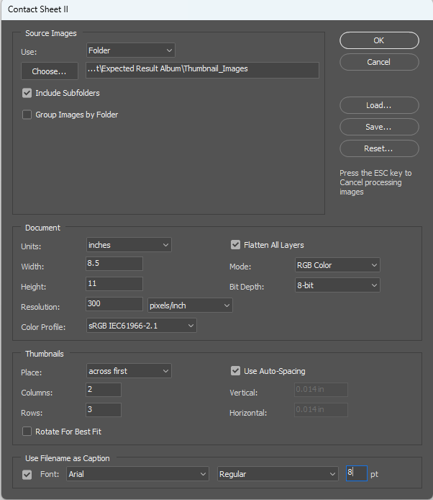

This will create one image per page with a 2x3 tiling of the thumbnails.
The export all those pages as a single PDF, by selecting File Automate PDF Presentation, selecting all open files:
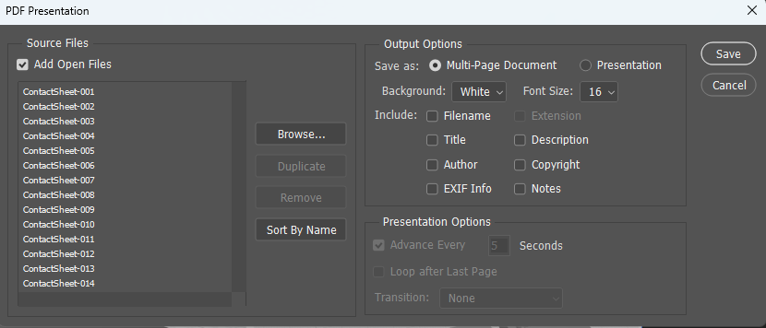
Click Save and select the output PDF file.
Select the High Quality Preset and select High compression:
